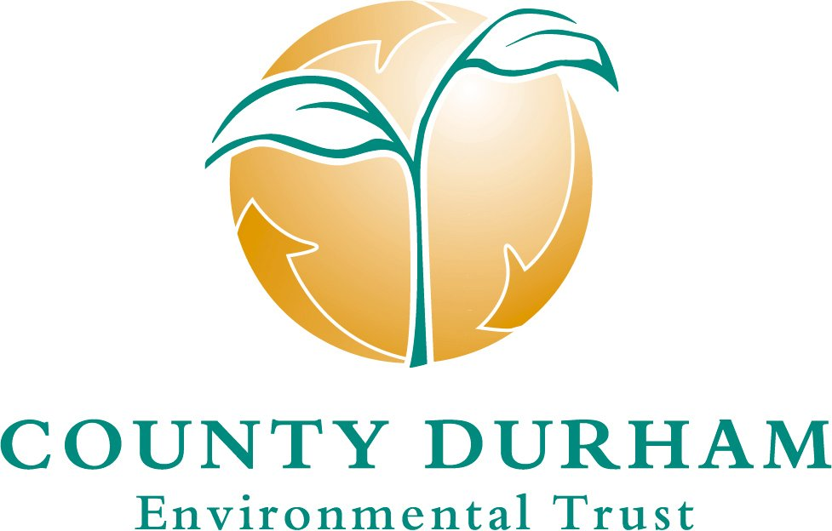

STRATEGY
April 2004



COUNTY DURHAM ENVIRONMENTAL TRUST LIMITED

A Company Limited by Guarantee. Registered in England and Wales, No. 3337599
Enrolled with ENTRUST - Enrolment No. 801057
web site: www.cdent.co.uk
Address: County Hall, Durham DH1 5UZ Telephone (0191) 383 4630 Fax (0191) 383 4631

Printed on EVOLVE Business recycled paper (100% post-consumer waste and chlorine free)

INTRODUCTION_____________________________________________________________

The County Durham Environmental Trust (CDENT) was established in April 1997 following an initiative of Durham County Council and the Durham County Waste Management Company now trading as Premier Waste Management Company Limited. It aims to maximise benefit to the environment by use of the Landfill Tax credit Scheme. CDENT, a limited company independent of local authorities and landfill operators, has been registered as an approved environmental body by ENTRUST – the national regulatory body established by H M Customs and Excise to oversee the scheme. CDENT is served by a Chairman, five non-executive directors, a part-time Company Secretary/Executive Officer and one full-time member of staff. PricewaterhouseCoopers LLP act as auditors.

This strategy, approved by the Board in April 2004, is a development of earlier versions issued in November 1997, April 1998, 2000, and 2002 which are now superseded. It takes into account Government changes to the Landfill Tax credit Scheme in 2003, whereby sustainable waste management has been deleted and biodiversity added to the list of approved objects under the Scheme.

II NATIONAL REQUIREMENTS_______________________________________________
The aim of the Landfill Tax credit Scheme under the Landfill Tax Regulations 1996 as amended in 1999 and 2003 is to encourage and enable landfill operators to support a specified range of environmental projects by allowing them a 90 per cent tax credit against their donations to registered environmental bodies. Currently these donations are capped at 6.8 per cent of the landfill operator’s Landfill Tax liabilities.

A registered environmental body must comply at all times with the following requirements:
- must be a non-profit distributing body
- must not be controlled – directly or indirectly – by a local authority or a landfill operator registered for Landfill Tax.

Approved environmental bodies may spend the donations which they receive from landfill site operators on approved objects for the protection of the environment summarised as follows with the sub-para references used in the Regulations.

(a) | reclamation, remediation, restoration or any other operation that facilitates the economic, social or environmental use of land where its use has been prevented or restricted because of previous use.
(b) | any operation intended to prevent or reduce any potential for pollution or to remedy or mitigate the effects of any pollution on land polluted by a previous activity.
((c) & (cc) | objects now deleted)
(d) | the provision, maintenance or improvement of a public park or other public amenity in the vicinity(i.e. within 10 miles) of a licensed landfill site, where it is for the protection of the environment.
(da) | the conservation or promotion of biological diversity through the provision, conservation, restoration or enhancement of a natural habitat; or the maintenance or recovery of a species in its natural habitat on land or in waters situated in the vicinity( i.e. within 10 miles) of a licensed landfill site.
(e) | the maintenance, repair or restoration of a building or other structure which is a place of religious worship or of historic or architectural interest and which is open to the public and situated in the vicinity (i.e. within 10 miles) of a licensed landfill site.
(f) | the provision of financial, administration and other similar services to other enrolled environmental bodies.

There are two other requirements which must be met:
* objects and work under the scheme must not uniquely benefit individual site operators who contribute to the organisation and receive a credit of Landfill Tax under the scheme.
* none of the work funded must be required to be carried out under any statutory notice or consent.

III MAIN PURPOSE OF CDENT __________________________________________
It is the aim of CDENT to benefit the environment by encouraging the use of the Landfill Tax credit Scheme and to use resultant resources on selected projects, programmes and activities which offer the prospect of significant and lasting benefit for the environment and people in the areas served by contributing waste management companies. CDENT will strive to maintain a position as a leader in good practice amongst environmental bodies operating in the United Kingdom.
IV OPERATING PRINCIPLES ___________________________________________
CDENT has adopted the following operating principles.

- Legislation and National Guidance
CDENT will follow national guidance from Government and ENTRUST in developing and approving projects for funding. As a Member of the Association of Distributive Environmental Bodies, CDENT will have due regard to the ADEB Code of Practice including the main Guidelines for Funders of Voluntary Organisations and the seven principles of public life identified by the Nolan Committee.

(2) Initiative
CDENT will define its strategy and priorities for funding and will update these from time to time in the light of changing circumstances. The strategy and priorities will be used in initiating ideas for discussion, in securing contributions and action on priorities, and in responding to approaches received.

CDENT will encourage those project promoters interested in the possibility of funding to discuss proposals informally with CDENT staff at an early stage so that guidance can be given in advance of a formal submission. Decisions on applications will be taken at quarterly meetings of the Board and notified to applicants, with accompanying reasons, wherever possible within two weeks.

Dates of board meetings and associated deadlines for scheme submissions will be publicised on the CDENT website and in the “Green Light” Newsletter.

(3) Local Partnerships and Liaison
CDENT will seek to complement rather than compete with other bodies already active for the benefit of the environment in the local area. It will seek to liaise with them in identifying and implementing priorities in ways which are compatible with the aims of local strategic partnerships and the statutory development plan framework, and contribute to the implementation of relevant national and local environmental strategies, programmes and targets. CDENT will make use of available information, expertise and services and will seek to maximise opportunities for matching funding and use of on-going programmes. Wherever appropriate CDENT will work through other bodies to implement its objectives.

(4) Access for All
CDENT will seek to stimulate public understanding and interest in its role and performance. Community commitment and involvement in schemes funded by CDENT will be sought and encouraged. Publication of research results and open public access to amenity and environmental improvement projects will be required. Information on the work of CDENT will be available on the web site www.cdent.co.uk, in press releases and the “Green Light” Newsletter.

(5) Financial Stewardship
CDENT will operate in accordance with good financial practice, including provision of adequate insurance and compliance with the requirements of the Landfill Tax Regulations and ENTRUST. Commitments will not be entered into until necessary resources are identified. Income not required immediately will be invested to ensure that resources are maximised under the Landfill Tax credit Scheme.

CDENT will consider assisting worthwhile projects unable to receive funding elsewhere but will also take into account the level of funding levered in from others when deciding on projects for support. Funding will only be confirmed on the basis of a signed Funding Agreement and money handed over only on receipt of proof of payments made in accordance with the provisions of the Funding Agreement.

(6) Sustainable Development
CDENT will seek to foster the principles of sustainable development and will require all applicants for funding to demonstrate that projects have regard to good practice in particular with regard to sustainable waste management and biodiversity.

V LANDFILL OPERATOR DONATIONS AND THIRD PARTY CONTRIBUTIONS ________________________________________________________
CDENT is willing to receive donations and contributions from landfill operators and from other sources and will discuss with donors as to how the resources might be deployed. Public acknowledgement will be given to the source of funds.

CDENT has reached an understanding with Premier Waste Management Company Limited that voluntary contributions under the Landfill Tax credit Scheme will be made on an on-going basis arising from Landfill Tax credit generating operations in County Durham, Darlington, Sunderland, Gateshead and South Tyneside areas.
CDENT is willing to enter into arrangements with other donors including waste management companies and other environmental bodies should an appropriate opportunity arise for relevant joint or single initiatives and will actively pursue this course of action. CDENT currently administers funds for Lafarge Aggregates in this respect.

Under the Landfill Tax credit Scheme, landfill operators may claim a tax credit worth 90 per cent of their donations to environmental bodies. The remaining 10 per cent may be borne by the landfill operator itself or by a contributing third party working in partnership with the landfill operator to reimburse all or part of the 10% required to release the Landfill Tax credit.

Contributing third parties can be private companies, public sector organisations, charities, voluntary bodies or individuals. They must however be independent of approved environmental bodies and must not gain a unique benefit from funds to which they have contributed. Third party donations must be paid directly to the landfill operator which must inform ENTRUST of their receipt.

CDENT will normally expect applicants for funding to arrange with a third party donor to provide the 10% donation required to draw down the Landfill Tax credits for CDENT supported projects. Where this is not achievable CDENT will explore the possibility of a donation from the Waste Management Company.

VI ACHIEVEMENTS TO DATE
Since its formation in 1997, CDENT has allocated around £7m to projects from donations made by Premier Waste Management Company Limited and around £150,000 from donations made by Lafarge Aggregates in the North of England. These donations have helped a wide variety of projects at over 250 locations throughout the CDENT area of interest.

Government funding targets have been fully met over the period to 31st March 2003 with the allocation of 69% of the available funds to sustainable waste management initiatives. CDENT funding has enabled significant research and development into innovative methods of processing and handling waste with the potential to reduce the amount of waste going to landfill by separating the mineral fraction into fuel or commercial recycling streams, and organic matter into soil conditioner. This research has been of direct benefit in informing the development of local waste management strategies. Other benefits have arisen from funded projects aimed at raising awareness on waste issues in the community and in piloting and promoting recycling initiatives. Significant progress has been made in introducing sustainable waste management into children’s education and a CDENT funded research centre has been established at Durham University as a platform for continuing research and development on sustainable waste management.

Targeted CDENT funding has enabled significant environmental improvements to be achieved in the vicinity of major landfill sites and area-wide initiatives for hedgerows, graffiti removal and small-scale community grants have led to improvements to the local environment at many locations across the area.

CDENT’s involvement in partnership schemes has played a significant factor in enabling funds by national and local authorities and organisations to be multiplied and deployed on town and village improvements, millennium greens, cycleways and improvements to public areas.

The introduction of government changes to the Landfill Tax credit Scheme transferring responsibilities for sustainable waste management and reducing funding levels available to environmental bodies required particular care in handling resources over a transitional period. CDENT has reviewed and adapted its methods of operation to take account of this changed context and anticipates being able to continue with funding other environmental projects at about existing levels.

A list of projects funded by CDENT to date is available on www.cdent.co.uk or on request from the CDENT Office.

VII PRIORITIES FOR FUNDING ______________________________________________
CDENT’s main interest lies in the physical implementation of landscape and habitat projects and in particular in green spaces accessible to the public. Feasibility studies and maintenance works will not normally be funded.

Consultation has been undertaken with a range of organisations with relevant environmental responsibilities and with the donating waste management company. From an assessment of potential environmental benefits to be gained, and bearing in mind other initiatives already underway in the area, CDENT has identified a number of priorities for funding. These priorities will be used to guide the selection of a range of projects of substantial and lasting benefit to form the focus for CDENT funding within the framework of the Landfill Tax objects summarised in Section II.
(1) To ameliorate and offset the direct impact of landfill sites and other licensed waste management sites within 10 miles of a landfill site on local communities by means of environmental improvement.

This objective will be pursued in several ways:

- On Site
CDENT will consider with Waste Management Companies any appropriate opportunities for additional restoration initiatives to follow on from those implemented in accordance with statutory consents.

- Immediate Locality
The Initial Strategy set out the intention of CDENT to target locations adjacent to or within close proximity of landfill sites and household waste sites operated by companies making voluntary donations in order to benefit initially those communities most directly affected.

Major environmental improvement schemes funded by CDENT have now been substantially completed in the vicinity of the following operational landfill sites.
* St Bedes, Birtley - Great North Forest
* Joint Stocks, Coxhoe - Five Villages Waste to Wildlife
* Chapman’s Well - Kyo Greenways
* Cockfield - Cockfield and Esperley improvements
- Todhills- Newfield Millennium Green and Jubilee Meadows Willington
Landfilling of waste is now completed at St Bede’s, Chapman’s Well and Cockfield.

The potential for improvements relating to the recently opened landfill site at Blaydon will be examined.

The possible scope for environmental improvements in the vicinity of other landfill and waste management sites will be kept under review.

- Area Initiatives and programmes
In view of the widespread distribution of present and former landfill sites, and in recognition that waste management operations inevitably impact on areas originating as well as transferring and receiving waste and on areas through which waste is transported, CDENT will seek to encourage area initiatives and programmes to promote environmental improvements throughout the area in which CDENT has an interest.

Programmes for hedgerow and stone-wall restoration and graffiti removal and a community grants scheme has enabled small scale environmental initiatives in over 150 locations throughout the area. Funding has also been given to a countywide programme of town and village environmental improvements under the Urban and Rural Renaissance partnership initiative.

CDENT will continue to encourage a range of landscape area initiatives and programmes. Although the existing broadly-based small community grant scheme administered on its behalf by the County Durham Foundation has now been completed, CDENT will itself consider requests for appropriate small project grants. Consideration will also be given to assisting small-scale community projects supported by Local Action 21 in the CDENT operating area.

(2) To conserve and promote biodiversity

Prior to the addition of the specific biodiversity object in the Landfill Tax amendment No 2 Regulations 2003 CDENT was able to give some support to biodiversity under object (d) relating to public amenity. The Hedgerow Partnership Scheme and some initiatives of benefit to wildlife on sites open to the public were assisted in this way.

CDENT will encourage all project promoters seeking Landfill Tax credit Scheme funding to have regard to the potential for conserving and promoting biodiversity.

CDENT will endeavour to support the continuation of the successful Hedgerow Partnership Scheme as a key element in fostering this objective. CDENT will consider supporting other eligible projects which are in line with priorities identified in the County Durham and Northern Region Biodiversity Action Plans.

While public access is not a requirement for this object under the Landfill Tax Regulations, it will be the intention of CDENT to secure this wherever achievable without detriment to the biodiversity objectives of the project.

(3) To assist local projects of wider significance

CDENT will continue to consider support for local initiatives of more than local significance eg projects relating to a broad area or which are of recognised regional or national importance.

From time to time opportunities may arise for funding to be attracted from national or European initiatives. In some cases significant local funding gaps exist. CDENT will consider giving some support provided the CDENT contribution facilitates a significant input of external funding in its area of interest.

Examples of schemes funded to date in this way have included Millennium Greens, national and regional cycleways, community forests, museums, attractions and parks of greater than local significance.

VIII OTHER FUNDING POSSIBILITIES _______________________________________
Consideration may be given to the possibility of funding other significant and sustainable proposals as opportunities arise and resources permit.

In view of the scale of resources likely to be required for the identified priorities, funding will not normally be available to meet general maintenance costs nor maintenance, repair or restoration costs of a building or structure which is a place of religious worship or of historic or architectural interest outlined under object (e) of the Landfill Tax regulations.

IX SUSTAINABLE WASTE MANAGEMENT
From 1 April 2003 the Government has transferred approximately two thirds of the funding previously available under the Landfill Tax credit Scheme to a separately administered public spending programme on sustainable waste management. Due to the change in regulations, CDENT is not able to allocate funds received after 1 April 2003 to sustainable waste management projects.

CDENT retains a continuing responsibility to monitor schemes it has already funded in this category to ensure continuing compliance with the requirements of the Landfill Tax Credit
Scheme. CDENT will also need to maintain a particular involvement in issues relating to the operation and completion of the following ongoing sustainable waste management schemes over the next two-year period:

- Aerobic Digester Thornley-a research project operated by a CDENT owned Company.
- Field Growing Trials on soil conditioner from the Aerobic Digester.
- CDENT Research Group at Durham University.
- Pyrolysis Research at Heighington.
- Weardale Railway reuse Ballast.
- Clow Beck Centre-sustainable living education project.
- Sustainable Development Guide for North East of England.
- Local Action 21 Waste Roundtable.
- Waste Wise-Schools education project.

X MONITORING
CDENT will monitor all funded projects as appropriate to ensure compliance with the terms of the Funding Agreement and the provisions of the Landfill Tax credit Scheme. Site visits and involvement in Steering groups and other meetings will be undertaken as appropriate. Quarterly progress reports will be considered at Board meetings.

Project promoters will be required to provide a statement of anticipated outcomes at the time of grant approval for monitoring during the project and on completion. In a limited number of cases where funding is transferred to a project via another environmental body which takes the monitoring responsibility in relation to the national scheme, CDENT will retain a continuing interest in the scheme to ensure compliance with the provision of the Funding Agreement.

XI REVIEW
CDENT will keep the Strategy under review and will revise it from time to time, as appropriate, in the light of changing circumstances.

- - - - e n d - - - -

